To Whom It May Concern,
You are receiving this paper because an NHS member wants to help out at a function organized by you. All National Honor Society members at Bloomfield High school are required to help out within the community as a requirement for maintaining membership in the NHS. If you deem the service by this NHS member to be adequate, please sign off on it below and indicate how long the NHS member helped for. Thank you.
Name of NHS Member:_______________________________________________________________

How the NHS member helped: ____________________________________________________

Was the service provided deemed acceptable? __________________ Date of Service: _____________

How many hours did the NHS Member Help for?___________________________________________

Signature of event organizer: __________________________________________________________

Thank you very much for your help in this matter.

Sincerely,

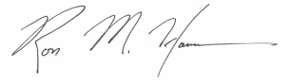
Ross Hanson
National Honor Society Advisor
Bloomfield High School

